THE SEATTLE SURGICAL SOCIETY

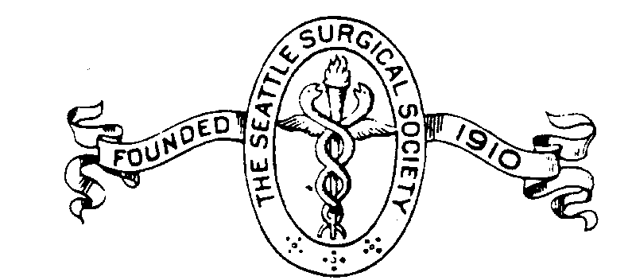

***OFFICERS:***

December 1, 2025

Dear Exhibitors:

The Seattle Surgical Society is hosting its 2025 Annual Meeting on Friday, February 7th at the Hyatt Olive 8 in downtown Seattle. This educational program will provide a variety of surgical cases and information that will be relevant to most surgeons’ practices. We anticipate approximately 100 surgeons from the Seattle metro area as well as surgeons in private practice in the neighboring cities.

The meeting will begin at 8:00 am. Exhibit hours will start from 7:30 until 4:30 pm. You will be provided with a 6-ft exhibit table.

We would like to request your participation to exhibit at our annual meeting. See Exhibitor form to review different levels of support.

Checks should be made out to Seattle Surgical Society. Our Tax ID number is **91-1128500**. Please send the check to:

Seattle Surgical Society

6817 208th St SW #90  
Lynnwood, WA 98046

Thanks so much for your support of our educational program. Please feel free to contact me at (206) 707-5336 if you have any questions or concerns.

Sincerely,

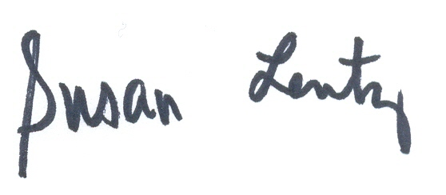

Susan Lentz

Administrator

**Andre Dick, MD**

*President*

**Nicole White, MD**

*President-Elect*

**Thomas Biehl, MD**

*Past President*

**Elina Quiroga, MD, MPH**

*Secretary*

**Laila Rashidi, MD**

*Treasurer*

**Kaj Johansen, MD***Historian*

**Jonathan Sham, MD**

*Program Chair*

***GOVERNORS:***

**Samantha Quade, M.D.**

**Jared Brandenberger, MD**

**Katherine Mandell, MD, MPH**

**Colette Inaba, MD**

**Abigail Wiebusch, MD**

***SOCIETY COORDINATOR:***

**Susan C. Lentz**

6817 208th St SW #90  
Lynnwood, WA 98046

Tel: (206) 707-5336

admin@seattlesurgical.org

**Website: www.seattlesurgical.org**